**SQL ASSIGNMENTS**

Create a database worker that should contain **first name, last name email, department, salary, Join Date** with 50 employees.

**Task-1**

1. Write an SQL query to fetch “FIRST_NAME” from the Worker table using the alias name as <WORKER_NAME>.

[SELECT](http://localhost/phpmyadmin/url.php?url=https://dev.mysql.com/doc/refman/8.0/en/select.html) FirstName AS Worker_Name from worker;

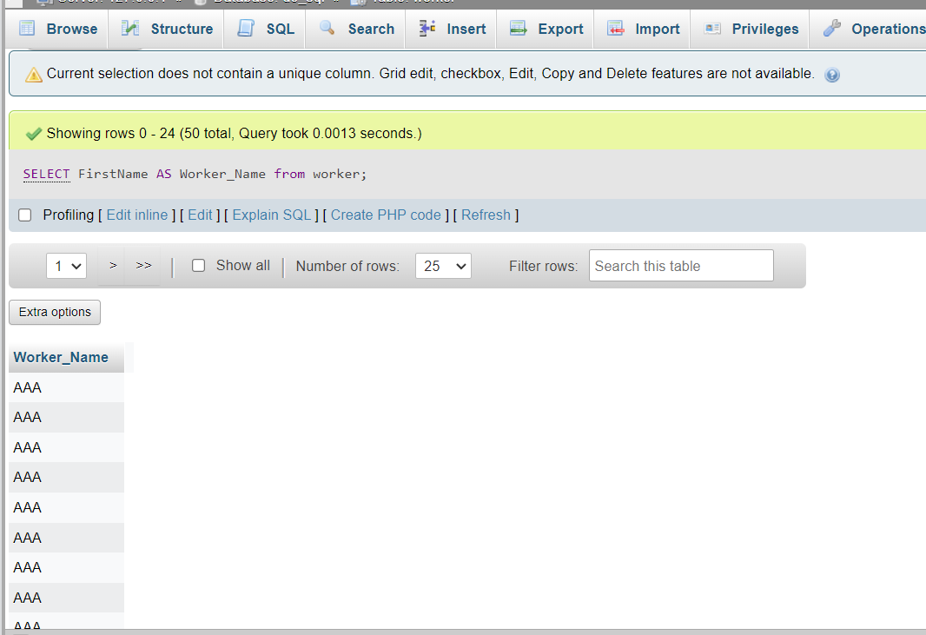

1. Write an SQL query to fetch unique values of DEPARTMENT from the Worker table.

[SELECT](http://localhost/phpmyadmin/url.php?url=https://dev.mysql.com/doc/refman/8.0/en/select.html) DISTINCT Department from worker;

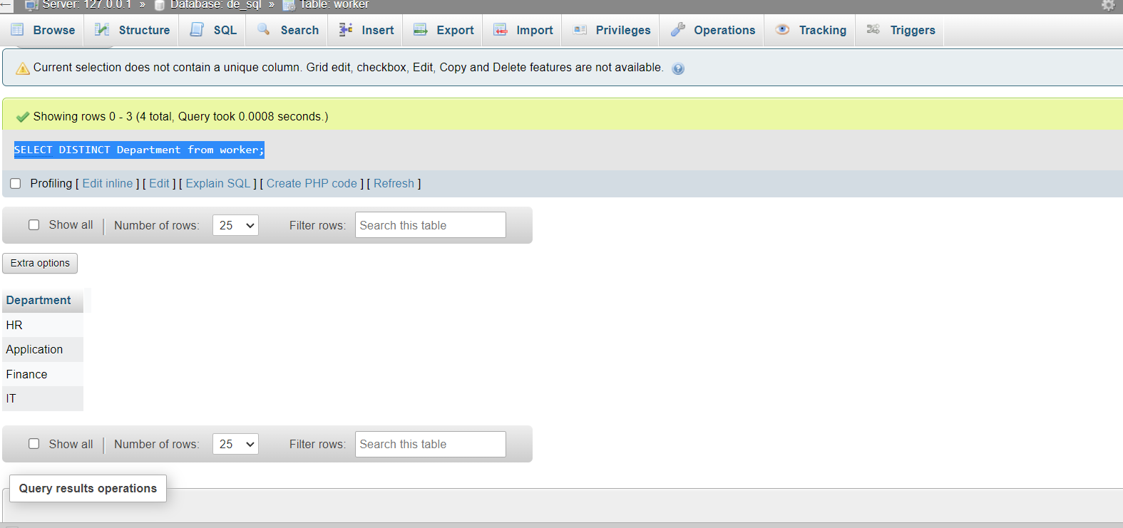

1. Write an SQL query to show the last 5 records from a table.

[SELECT](http://localhost/phpmyadmin/url.php?url=https://dev.mysql.com/doc/refman/8.0/en/select.html) * FROM worker ORDER BY LastName DESC LIMIT 5;

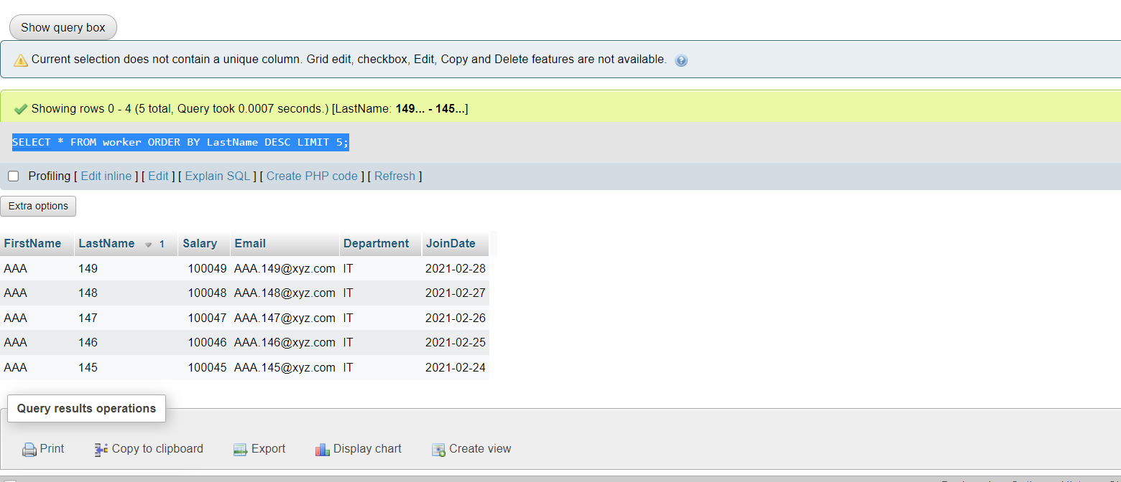

**Task-2**

1. Write an SQL query to print the first three characters of FIRST_NAME from Worker

[SELECT](http://localhost/phpmyadmin/url.php?url=https://dev.mysql.com/doc/refman/8.0/en/select.html) SUBSTRING(FirstName, 1, 3) AS first3 FROM worker;

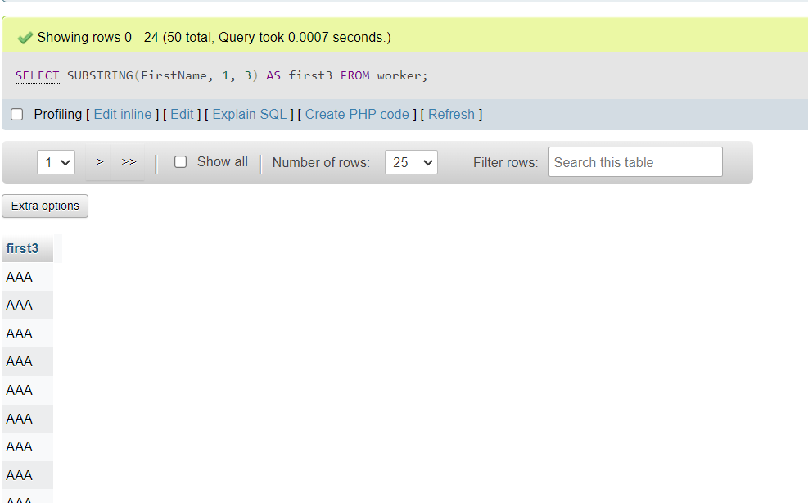

1. Write an SQL query to find the position of the alphabet (‘a’) in the first name

[SELECT](http://localhost/phpmyadmin/url.php?url=https://dev.mysql.com/doc/refman/8.0/en/select.html) Locate('A',FirstName) AS charind FROM worker;

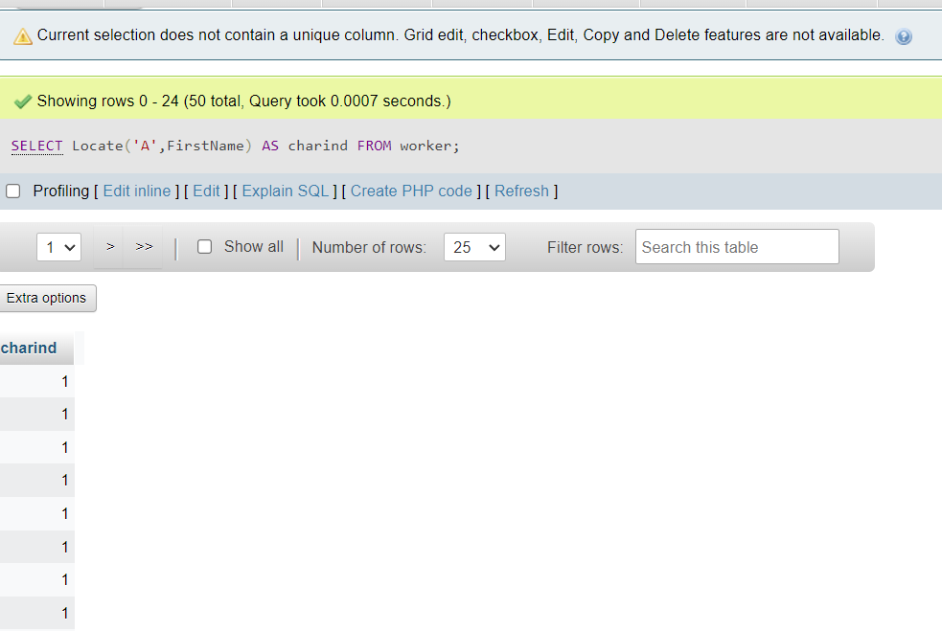

1. Write an SQL query to print the name of employees who have the highest salary in each department.

[SELECT](http://localhost/phpmyadmin/url.php?url=https://dev.mysql.com/doc/refman/8.0/en/select.html) FirstName,LastName, [MAX](http://localhost/phpmyadmin/url.php?url=https://dev.mysql.com/doc/refman/8.0/en/aggregate-functions.html%23function_max)(Salary) FROM worker;

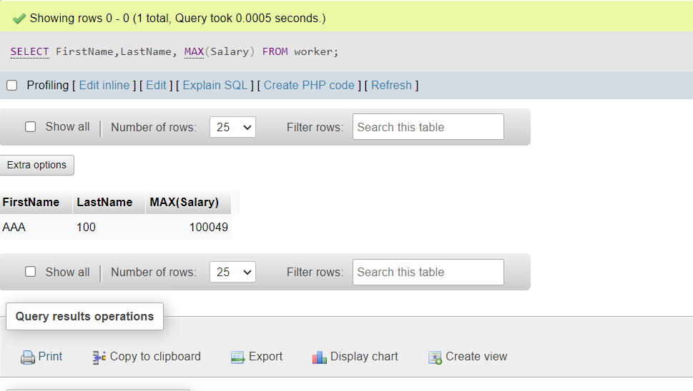

**Task-3**

1. Write an SQL query to print the FIRST_NAME from the Worker table after removing white spaces from the right side.

[SELECT](http://localhost/phpmyadmin/url.php?url=https://dev.mysql.com/doc/refman/8.0/en/select.html) RTRIM(FirstName) FROM worker;

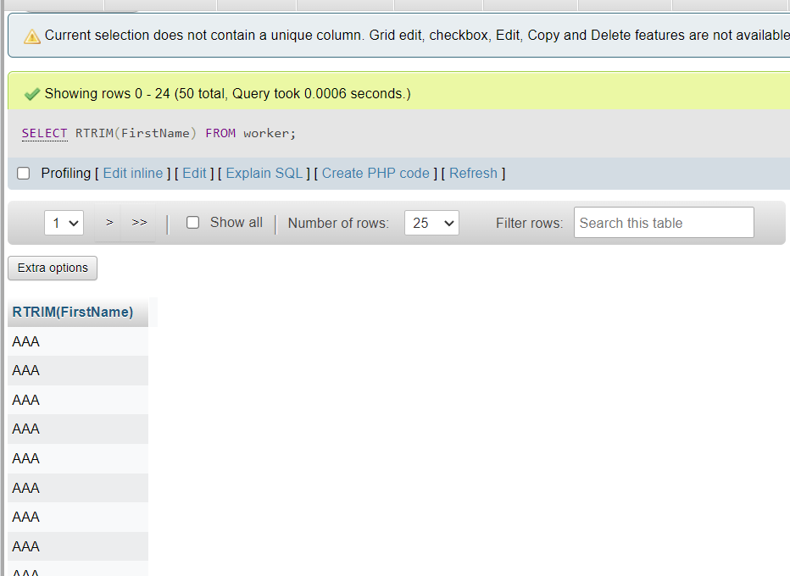

1. Write an SQL query that fetches the unique values of DEPARTMENT from the Worker table and prints its length.

[SELECT](http://localhost/phpmyadmin/url.php?url=https://dev.mysql.com/doc/refman/8.0/en/select.html) DISTINCT(Department),length(Department)as length FROM worker;

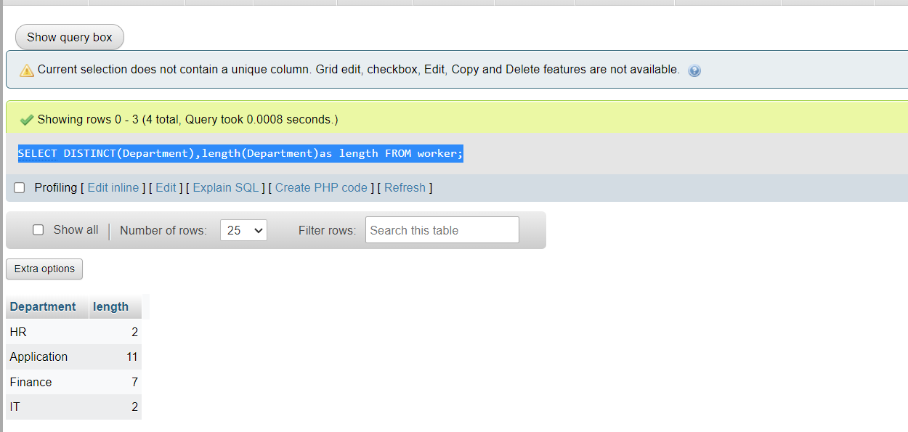

1. Write an SQL query to fetch nth max salaries from a table.

[SELECT](http://localhost/phpmyadmin/url.php?url=https://dev.mysql.com/doc/refman/8.0/en/select.html) DISTINCT Salary AS nthHighest FROM worker ORDER BY Salary DESC LIMIT 1 OFFSET 4;

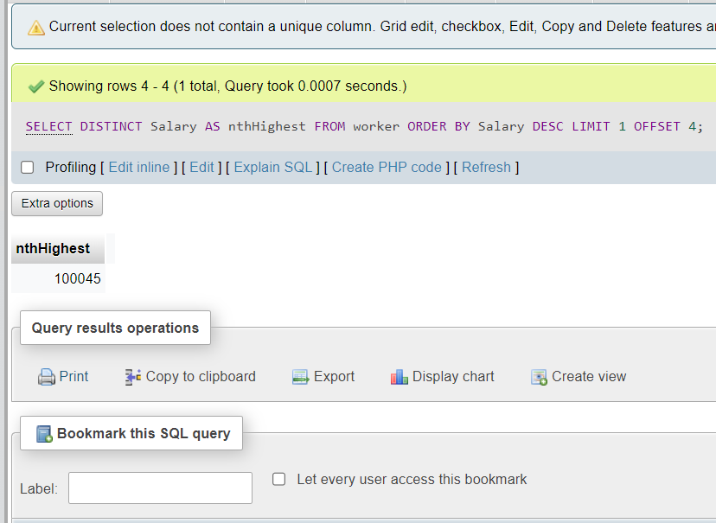

**Task-4**

1. Write an SQL query to print the FIRST_NAME from the Worker table after replacing ‘a’ with ‘A’.

SELECT REPLACE(FirstName, 'A', 'a') as replacedName FROM worker;

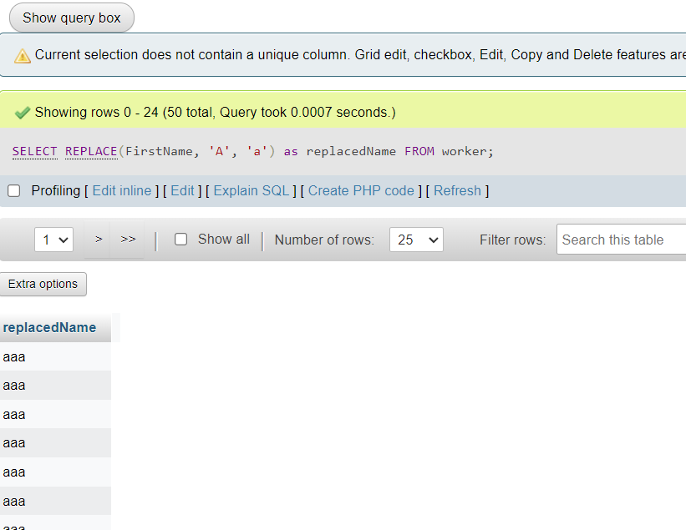

1. Write an SQL query to print all Worker details from the Worker table order FIRST_NAME Ascending and DEPARTMENT Descending.

SELECT *

FROM worker

ORDER BY FirstName ASC, Department DESC;

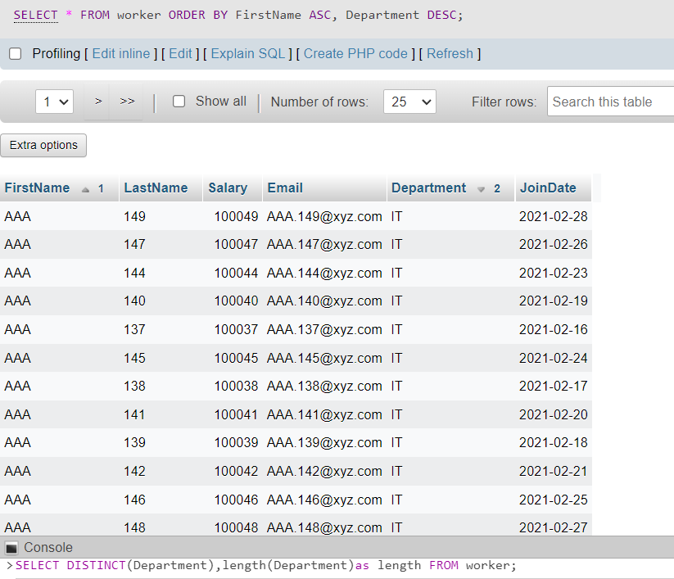

1. Write an SQL query to fetch the names of workers who earn the highest salary.

[SELECT](http://localhost/phpmyadmin/url.php?url=https://dev.mysql.com/doc/refman/8.0/en/select.html) * FROM worker ORDER BY Salary DESC LIMIT 5;

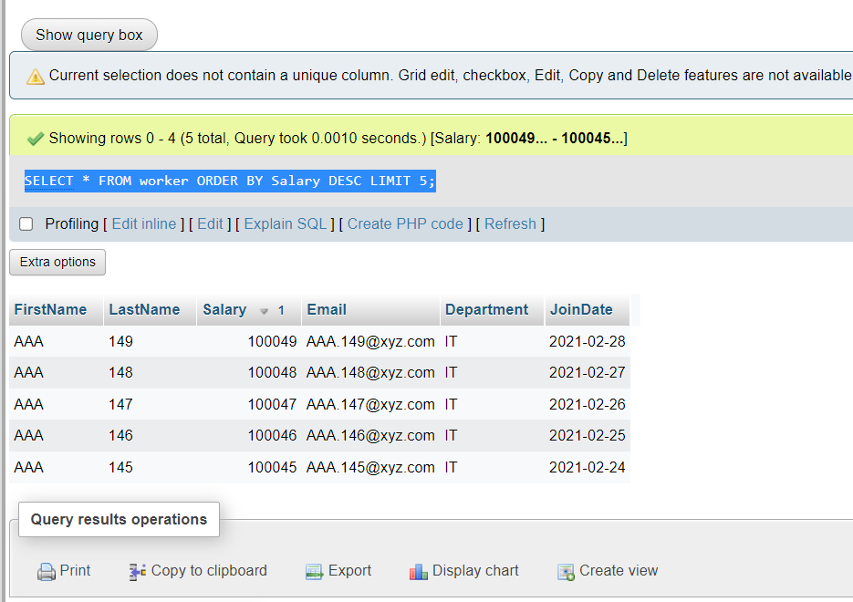

**Task-5**

1. Write an SQL query to print details of workers excluding first names, “Ramesh” and “Santhosh” from the Worker table.

Before Display: [SELECT](http://localhost/phpmyadmin/url.php?url=https://dev.mysql.com/doc/refman/8.0/en/select.html) * FROM `worker` WHERE FirstName != 'Santhosh' [AND](http://localhost/phpmyadmin/url.php?url=https://dev.mysql.com/doc/refman/8.0/en/logical-operators.html%23operator_and) FirstName != 'Ramesh';

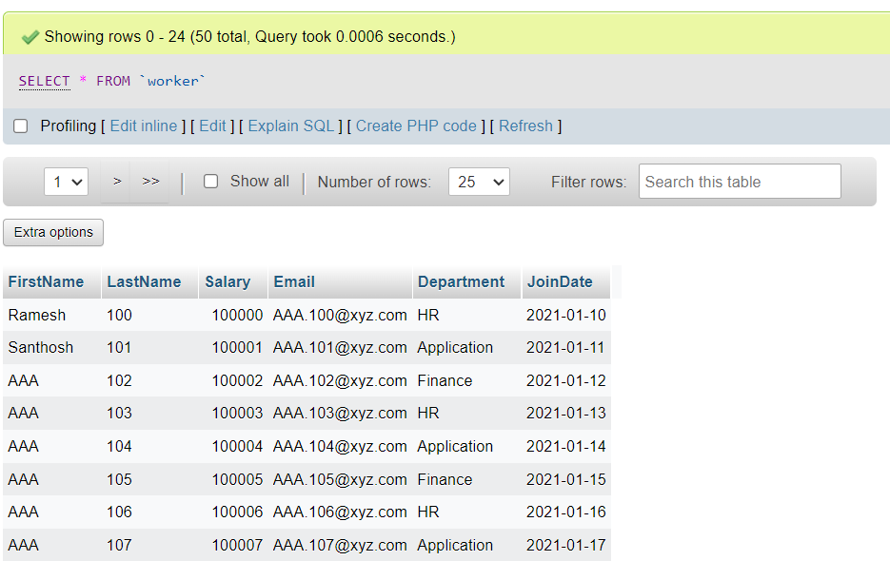 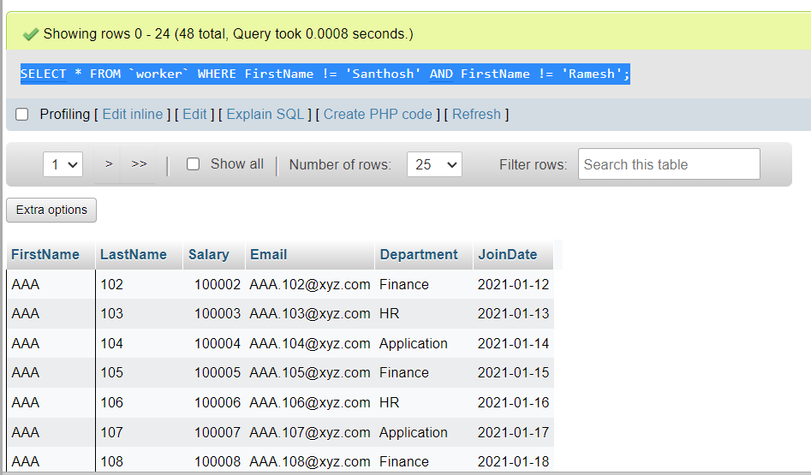

1. Write an SQL query to print details of the Workers whose FIRST_NAME ends with ‘h’ and contains six alphabets.

[Select](http://localhost/phpmyadmin/url.php?url=https://dev.mysql.com/doc/refman/8.0/en/select.html) FirstName ,LastName FROM worker WHERE SUBSTRING(FirstName, LENgth(FirstName),1) = 'h';

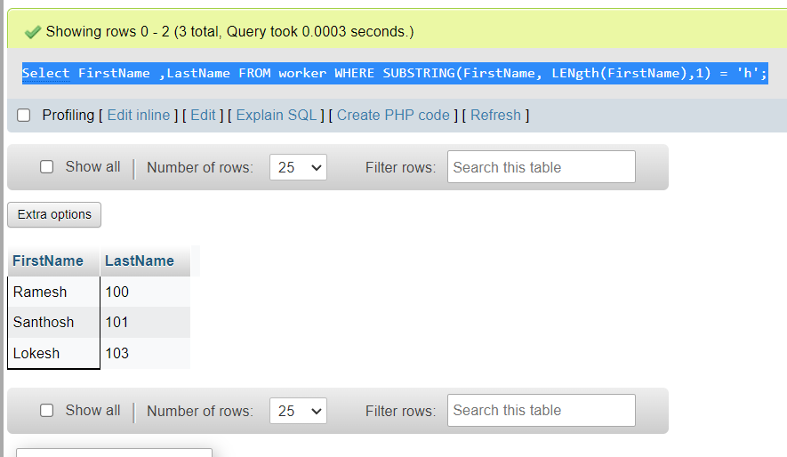

1. Write a query to validate Email of Employee (email should have first name last name and guvi.com example (first name=Kamal last name= raja and the mail id should be [kamalraja@guvi.com](mailto:kamalraja@guvi.com)).

**Task-6**

1. Write an SQL query to print details of the Workers who have joined in March ’2021.

[SELECT](http://localhost/phpmyadmin/url.php?url=https://dev.mysql.com/doc/refman/8.0/en/select.html) * FROM worker WHERE JoinDate >= '2021/01/01' [AND](http://localhost/phpmyadmin/url.php?url=https://dev.mysql.com/doc/refman/8.0/en/logical-operators.html%23operator_and) JoinDate <= '2021/01/31'; (Since no data available in march changed the select criteria

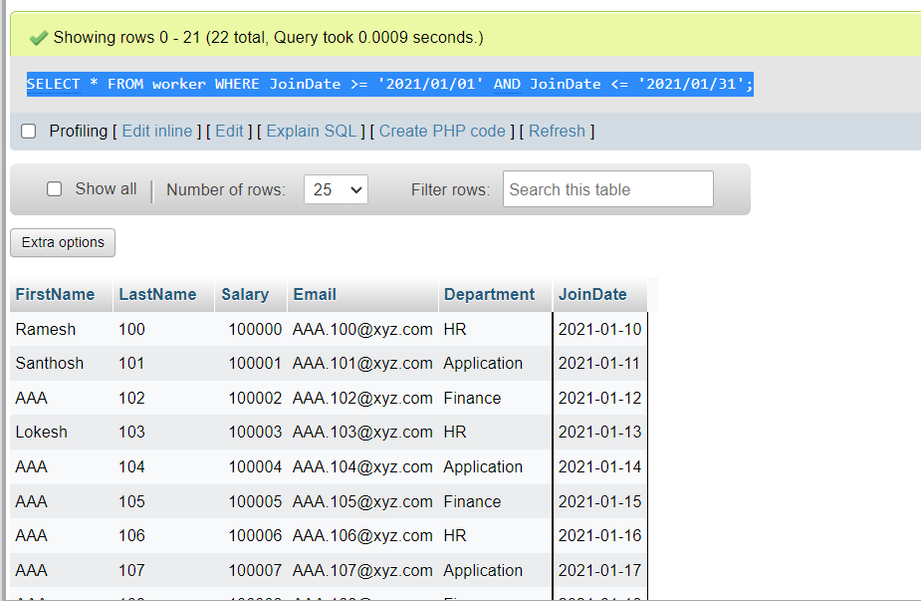

1. Write an SQL query to fetch duplicates that have matching data in some fields of a table.

WITH CTE(FirstName, LastName, Department, DuplicateCount) AS ([SELECT](http://localhost/phpmyadmin/url.php?url=https://dev.mysql.com/doc/refman/8.0/en/select.html) FirstName, LastName, Department, ROW_NUMBER() OVER(PARTITION BY Department ORDER BY FirstName) AS DuplicateCount FROM worker) [SELECT](http://localhost/phpmyadmin/url.php?url=https://dev.mysql.com/doc/refman/8.0/en/select.html) * FROM CTE;

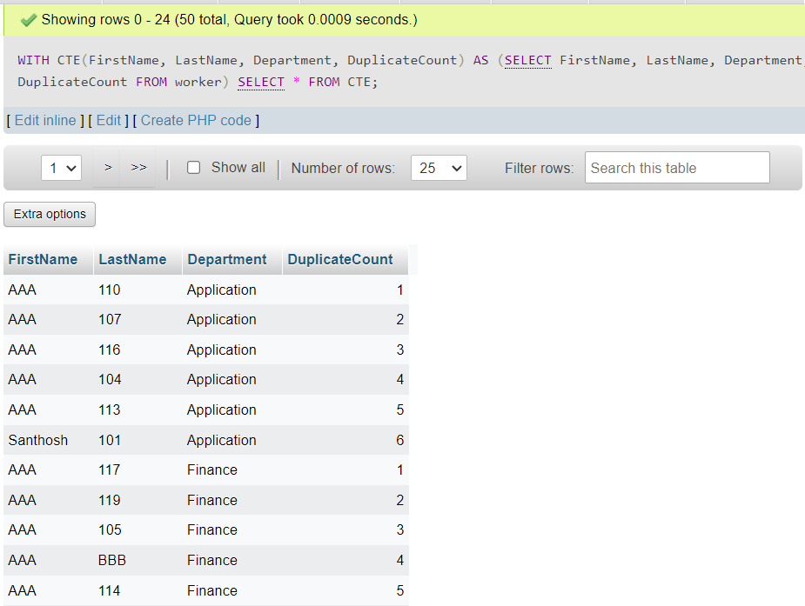

1. How to remove duplicate rows from the Employees table.

[DELETE](http://localhost/phpmyadmin/url.php?url=https://dev.mysql.com/doc/refman/8.0/en/delete.html) FROM worker WHERE Salary [NOT](http://localhost/phpmyadmin/url.php?url=https://dev.mysql.com/doc/refman/8.0/en/logical-operators.html%23operator_not) [IN](http://localhost/phpmyadmin/url.php?url=https://dev.mysql.com/doc/refman/8.0/en/comparison-operators.html%23function_in) ( [SELECT](http://localhost/phpmyadmin/url.php?url=https://dev.mysql.com/doc/refman/8.0/en/select.html) [MAX](http://localhost/phpmyadmin/url.php?url=https://dev.mysql.com/doc/refman/8.0/en/aggregate-functions.html%23function_max)(Salary) AS MaxRecordID FROM worker GROUP BY FirstName, LastName );

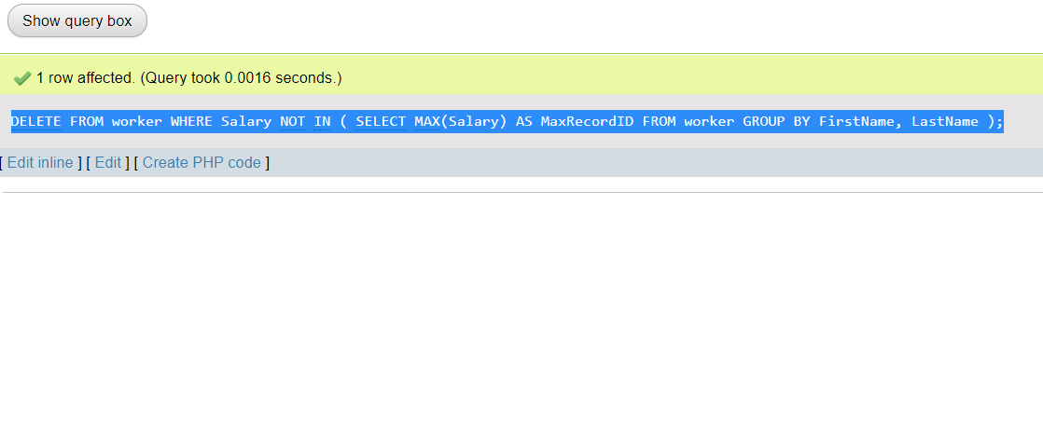

**Task-7**

1. Write an SQL query to show only odd rows from a table.

[SELECT](http://localhost/phpmyadmin/url.php?url=https://dev.mysql.com/doc/refman/8.0/en/select.html) * FROM `worker` WHERE ID % 2 = 0;

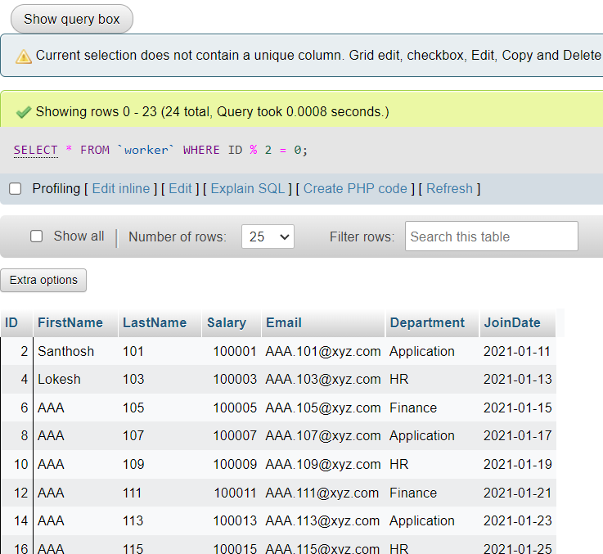

1. Write an SQL query to clone a new table from another table.

[CREATE](http://localhost/phpmyadmin/url.php?url=https://dev.mysql.com/doc/refman/8.0/en/create-table.html) [TABLE](http://localhost/phpmyadmin/url.php?url=https://dev.mysql.com/doc/refman/8.0/en/create-table.html) workernew [LIKE](http://localhost/phpmyadmin/url.php?url=https://dev.mysql.com/doc/refman/8.0/en/string-comparison-functions.html%23operator_like) worker;

[INSERT](http://localhost/phpmyadmin/url.php?url=https://dev.mysql.com/doc/refman/8.0/en/insert.html) INTO workernew [SELECT](http://localhost/phpmyadmin/url.php?url=https://dev.mysql.com/doc/refman/8.0/en/select.html) * FROM worker;

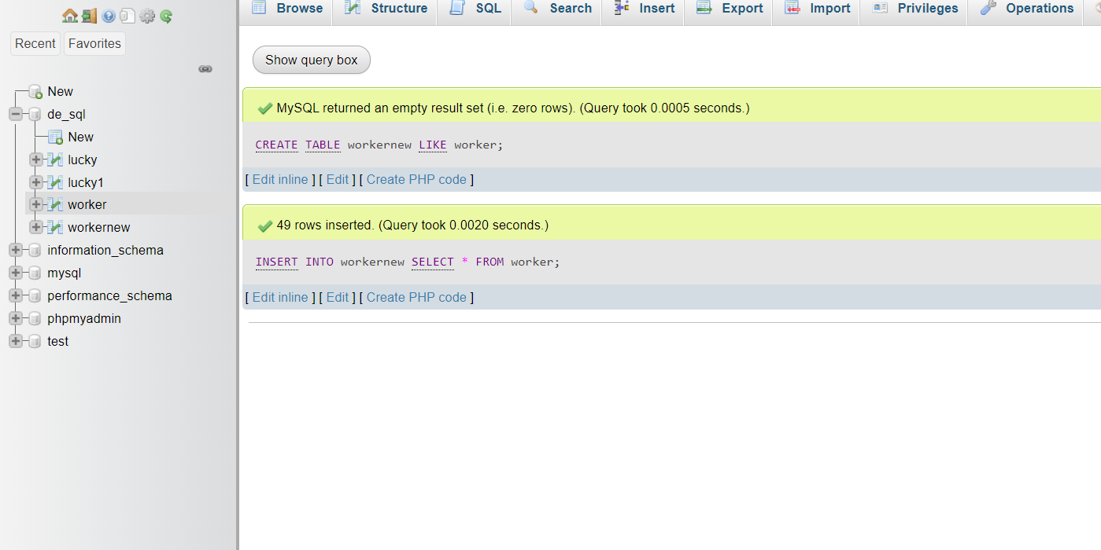

**Task-8**

1. Write an SQL query to fetch intersecting records of two tables.

[SELECT](http://localhost/phpmyadmin/url.php?url=https://dev.mysql.com/doc/refman/8.0/en/select.html) worker.FirstName,worker.ID FROM worker WHERE worker.ID [IN](http://localhost/phpmyadmin/url.php?url=https://dev.mysql.com/doc/refman/8.0/en/comparison-operators.html%23function_in) ([SELECT](http://localhost/phpmyadmin/url.php?url=https://dev.mysql.com/doc/refman/8.0/en/select.html) workernew.ID FROM workernew);

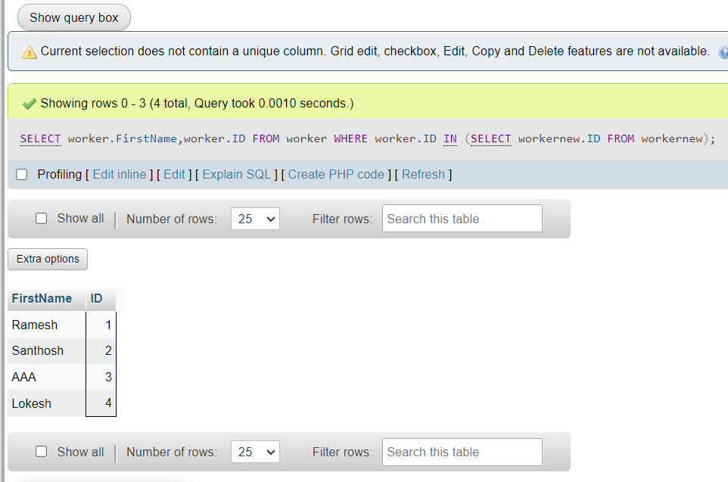

1. Write an SQL query to show records from one table that another table does not have.

[SELECT](http://localhost/phpmyadmin/url.php?url=https://dev.mysql.com/doc/refman/8.0/en/select.html) FirstName,Department,ID,LastName FROM workernew WHERE [NOT](http://localhost/phpmyadmin/url.php?url=https://dev.mysql.com/doc/refman/8.0/en/logical-operators.html%23operator_not) EXISTS ([SELECT](http://localhost/phpmyadmin/url.php?url=https://dev.mysql.com/doc/refman/8.0/en/select.html) * FROM worker WHERE worker.LastName = workernew.LastName);

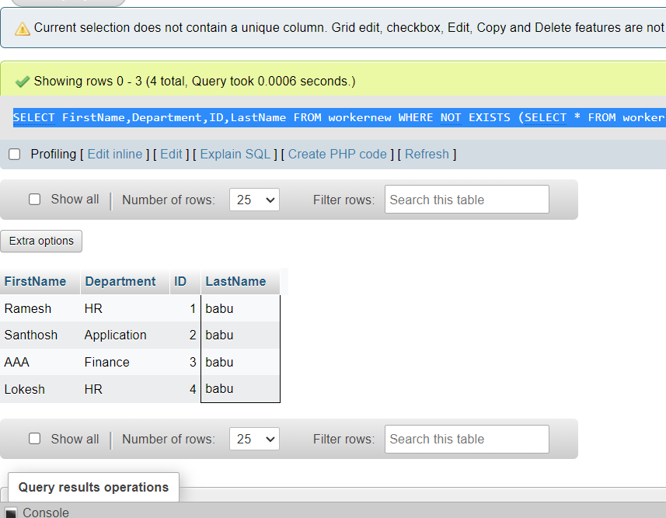

**Task-9**

1. Write an SQL query to show the top n (say 15) records of a table.

SELECT * FROM `worker` ORDER BY ID DESC LIMIT 15;

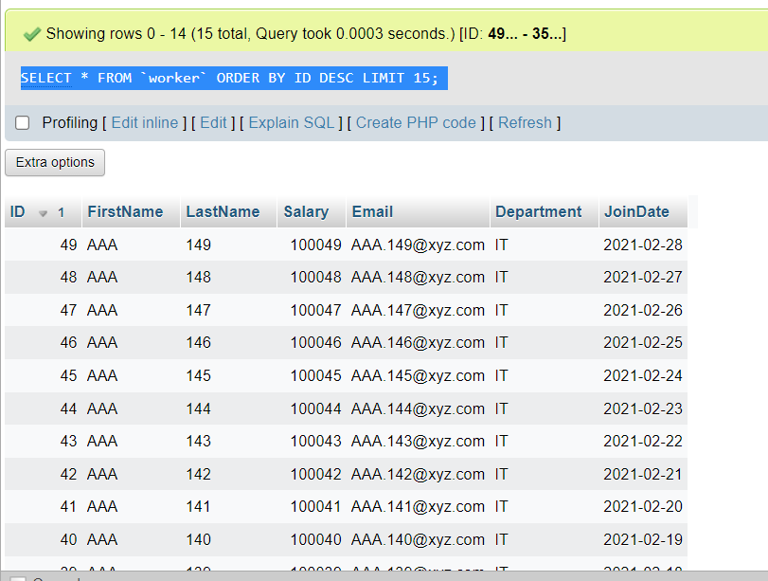

1. Write an SQL query to determine the nth (say n=10) highest salary from a table.

With Cust AS ( [SELECT](http://localhost/phpmyadmin/url.php?url=https://dev.mysql.com/doc/refman/8.0/en/select.html) FirstName, Salary, ROW_NUMBER() OVER (ORDER BY Salary DESC) as RowNumber FROM workernew ) [select](http://localhost/phpmyadmin/url.php?url=https://dev.mysql.com/doc/refman/8.0/en/select.html) * from Cust Where RowNumber Between 10 [AND](http://localhost/phpmyadmin/url.php?url=https://dev.mysql.com/doc/refman/8.0/en/logical-operators.html%23operator_and) 10;

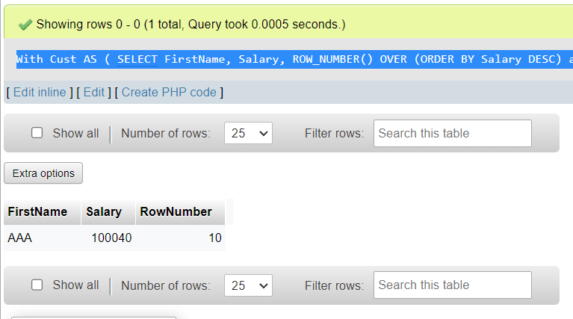

**Task-10**

1. Write an SQL query to determine the 8th highest salary without using TOP or LIMIT methods.

With Cust AS ( [SELECT](http://localhost/phpmyadmin/url.php?url=https://dev.mysql.com/doc/refman/8.0/en/select.html) FirstName, Salary, ROW_NUMBER() OVER (ORDER BY Salary DESC) as RowNumber FROM workernew ) [select](http://localhost/phpmyadmin/url.php?url=https://dev.mysql.com/doc/refman/8.0/en/select.html) * from Cust Where RowNumber Between 8 [AND](http://localhost/phpmyadmin/url.php?url=https://dev.mysql.com/doc/refman/8.0/en/logical-operators.html%23operator_and) 8;

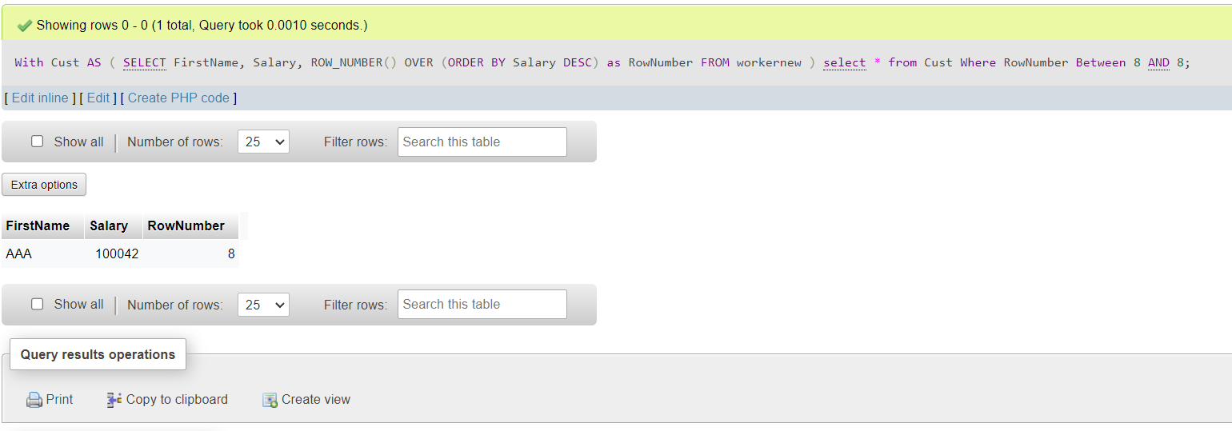

1. Write an SQL query to fetch the list of employees with the same salary.

[select](http://localhost/phpmyadmin/url.php?url=https://dev.mysql.com/doc/refman/8.0/en/select.html) * from workernew where Salary [in](http://localhost/phpmyadmin/url.php?url=https://dev.mysql.com/doc/refman/8.0/en/comparison-operators.html%23function_in) ([select](http://localhost/phpmyadmin/url.php?url=https://dev.mysql.com/doc/refman/8.0/en/select.html) Salary from workernew group by Salary having [count](http://localhost/phpmyadmin/url.php?url=https://dev.mysql.com/doc/refman/8.0/en/aggregate-functions.html%23function_count)(1)>1);

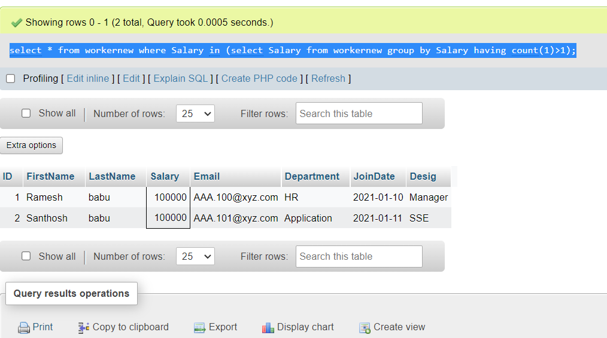

Attach the query with the output table screenshot with the assignment.